Sukhpreet Jena
Superset ID:-6399056
WEEK 7 REACT
EX 09 PLAYERS
IndianPlayers.js
import React from 'react';
const IndianPlayers = () => {
const teamPlayers = [
"Rohit", "Virat", "Rahul", "Gill", "Surya", "Hardik",
"Jadeja", "Iyer", "Pant", "Bumrah", "Shami"
];

const oddTeam = teamPlayers.filter((_, index) => index % 2 === 0);
const evenTeam = teamPlayers.filter((_, index) => index % 2 !== 0);

const T20Players = ["Rohit", "Virat", "Gill"];
const RanjiPlayers = ["Pujara", "Rahane", "Karun Nair"];

// Merge using spread operator
const allPlayers = [...T20Players, ...RanjiPlayers];

return (
<div>
<h2>Odd Team Players</h2>
<ul>
{oddTeam.map((player, index) => <li key={index}>{player}</li>)}
</ul>

<h2>Even Team Players</h2>
<ul>
{evenTeam.map((player, index) => <li key={index}>{player}</li>)}
</ul>

<h2>Merged T20 & Ranji Players</h2>
<ul>
{allPlayers.map((player, index) => <li key={index}>{player}</li>)}
</ul>
</div>
);
};
export default IndianPlayers;
ListofPlayers.js
import React from 'react';

const ListofPlayers = () => {
const players = [
{ name: "Rohit Sharma", score: 92 },
{ name: "Virat Kohli", score: 88 },
{ name: "KL Rahul", score: 69 },
{ name: "Shubman Gill", score: 55 },
{ name: "Suryakumar Yadav", score: 75 },
{ name: "Hardik Pandya", score: 65 },
{ name: "Ravindra Jadeja", score: 72 },
{ name: "Shreyas Iyer", score: 58 },
{ name: "Rishabh Pant", score: 81 },
{ name: "Jasprit Bumrah", score: 62 },
{ name: "Mohammed Shami", score: 70 }
];

const filteredPlayers = players.filter(player => player.score >= 70);

return (
<div>
<h2>All Players</h2>
<ul>
{players.map((player, index) => (
<li key={index}>{player.name} - {player.score}</li>
))}
</ul>

<h3>Players with score ≥ 70</h3>
<ul>
{filteredPlayers.map((player, index) => (
<li key={index}>{player.name} - {player.score}</li>
))}
</ul>
</div>
);
};
export default ListofPlayers;
App.js
import React from 'react';
import ListofPlayers from './ListofPlayers';
import IndianPlayers from './IndianPlayers';

function App() {
const flag = false; // change to false to toggle

return (
<div className="App">
<h1>🏏 Welcome to Cricket App</h1>
{flag ? <ListofPlayers /> : <IndianPlayers />}
</div>
);
}
export default App;
OUTOUT:
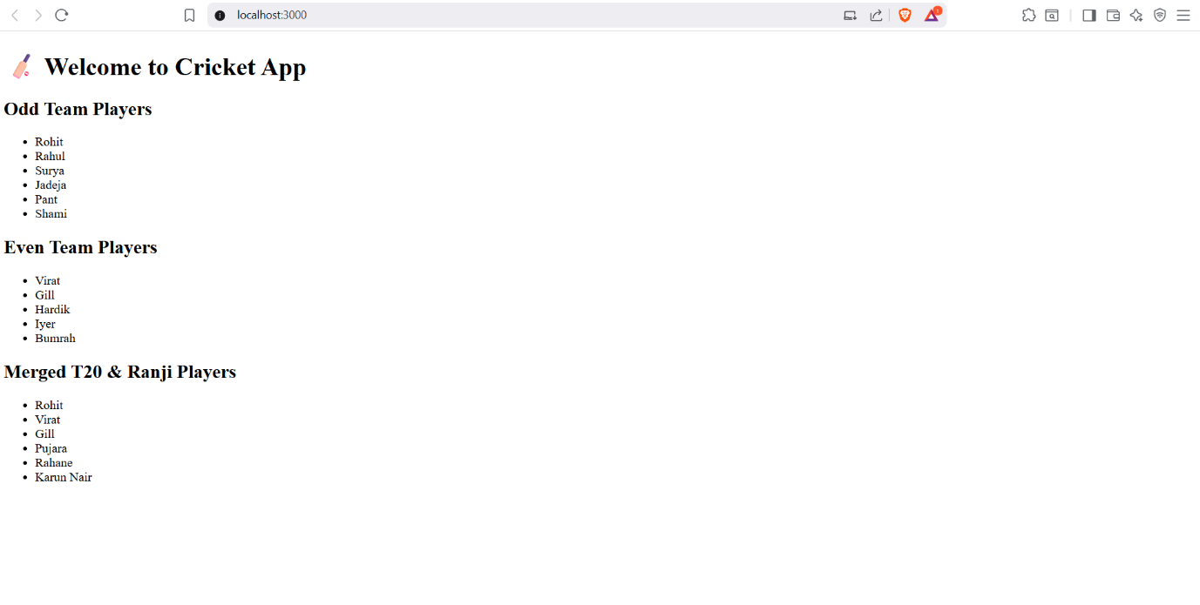
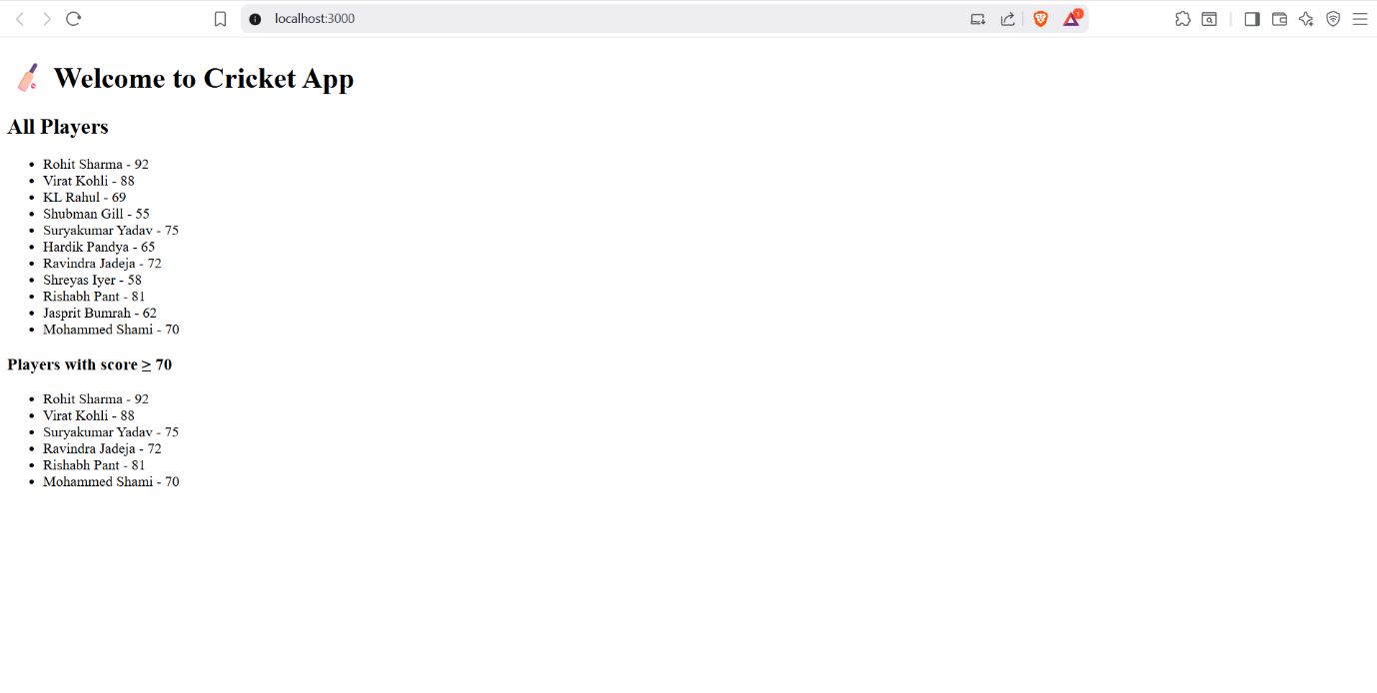
EX 10 OFFICERENTALAPP
App.js
import React from 'react';
function App() {
const office = {
name: 'Indigo Workspace',
rent: 55000,
address: '123 Tech Park, Bengaluru',
image: 'https://via.placeholder.com/400x200.png?text=Office+Space'
};
const officeList = [
{
name: 'Indigo Workspace',
rent: 55000,
address: '123 Tech Park, Bengaluru',
},
{
name: 'GreenHub Office',
rent: 72000,
address: '45 Startup Lane, Chennai',
},
{
name: 'SkyView Workspaces',
rent: 60000,
address: '88 Business Bay, Hyderabad',
}
];
const getRentStyle = (rent) => {
return {
color: rent > 60000 ? 'green' : 'red',
fontWeight: 'bold'
};
};

return (
<div style={{ padding: '20px', fontFamily: 'Arial' }}>
<h1>Office Space Rental App</h1>
<img src={office.image} alt="Office Space" style={{ width: '400px', height: '200px' }} />
<h2>{office.name}</h2>
<p style={getRentStyle(office.rent)}>Rent: ₹{office.rent}</p>
<p>Address: {office.address}</p>

<hr />
<h2>Available Office Spaces:</h2>
{officeList.map((item, index) => (
<div key={index} style={{ marginBottom: '20px' }}>
<h3>{item.name}</h3>
<p style={getRentStyle(item.rent)}>Rent: ₹{item.rent}</p>
<p>Address: {item.address}</p>
</div>
))}
</div>
);
}
export default App;
OUTPUT
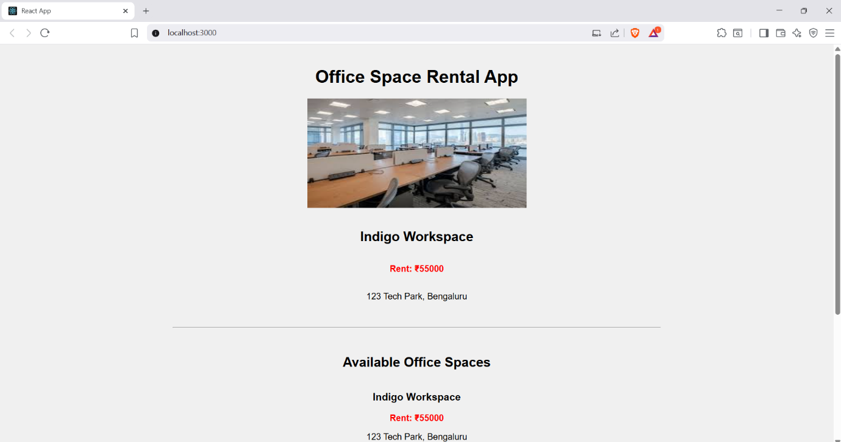
EX 11 EVENTEXAMPLESAPP
App.js
import React, { Component } from "react";
import CurrencyConvertor from "./CurrencyConvertor";

class App extends Component {
constructor(props) {
super(props);
this.state = {
counter: 0,
};

// Binding this manually for class method
this.handleDecrement = this.handleDecrement.bind(this);
}

// Increment with multiple methods
handleIncrement = () => {
this.incrementValue();
this.sayHello();
};

incrementValue = () => {
this.setState((prevState) => ({
counter: prevState.counter + 1,
}));
};

sayHello = () => {
console.log("Hello! Counter is increasing.");
};

handleDecrement() {
this.setState((prevState) => ({
counter: prevState.counter - 1,
}));
}

// Welcome message function
sayWelcome = (message) => {
alert(message);
};

// Synthetic Event Handler
handleClick = (event) => {
alert("I was clicked");
console.log("Synthetic Event: ", event);
};

render() {
return (
<div style={{ textAlign: "center", marginTop: "50px" }}>
<h1>React Event Handling Examples</h1>

<h2>Counter: {this.state.counter}</h2>
<button onClick={this.handleIncrement}>Increment</button>&nbsp;
<button onClick={this.handleDecrement}>Decrement</button>
<hr style={{ margin: "30px 0" }} />
<button onClick={() => this.sayWelcome("Welcome to React Events!")}>
Say Welcome
</button>
<hr style={{ margin: "30px 0" }} />
<button onClick={this.handleClick}>Click Me (Synthetic Event)</button>
<hr style={{ margin: "30px 0" }} />
<CurrencyConvertor />
</div>
);
}
}
export default App;
CurrencyConvertor.js
import React, { useState } from "react";
function CurrencyConvertor() {
const [rupees, setRupees] = useState("");
const [euro, setEuro] = useState("");

const handleSubmit = (e) => {
e.preventDefault();
const euroValue = (parseFloat(rupees) / 90).toFixed(2);
setEuro(euroValue);
};
return (
<div>
<h2>Currency Converter (INR → Euro)</h2>
<form onSubmit={handleSubmit}>
<input
type="number"
placeholder="Enter amount in INR"
value={rupees}
onChange={(e) => setRupees(e.target.value)}
/>
&nbsp;
<button type="submit">Convert</button>
</form>
{euro && (
<p>
€ {euro} EUR (from ₹{rupees})
</p>
)}
</div>
);
}
export default CurrencyConvertor;
OUTPUT
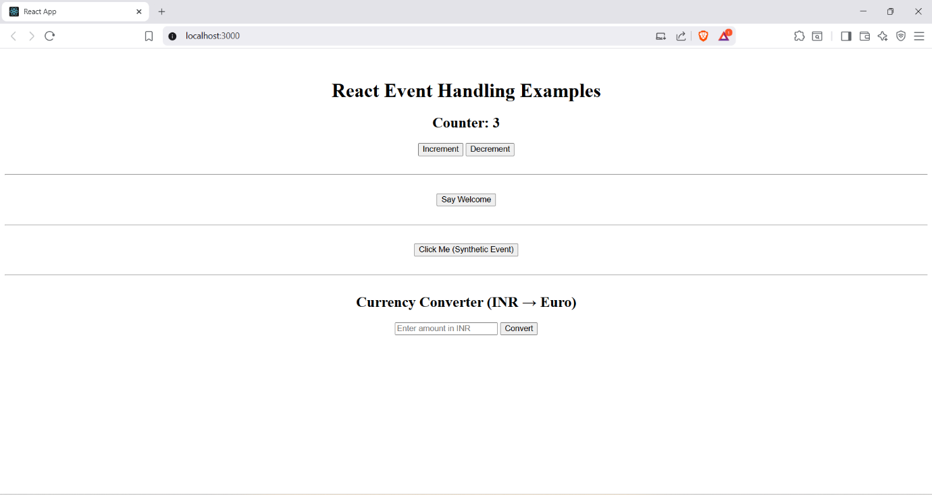
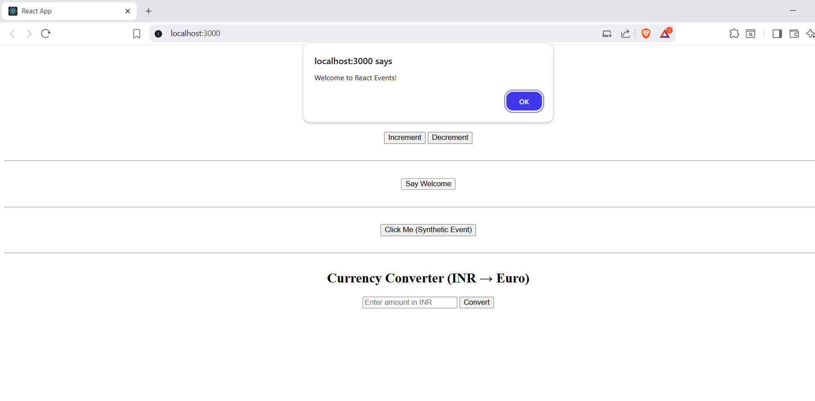
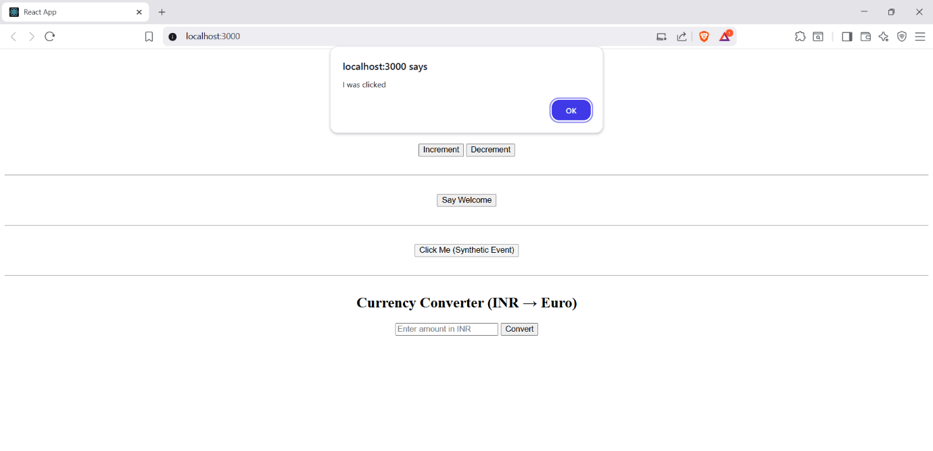
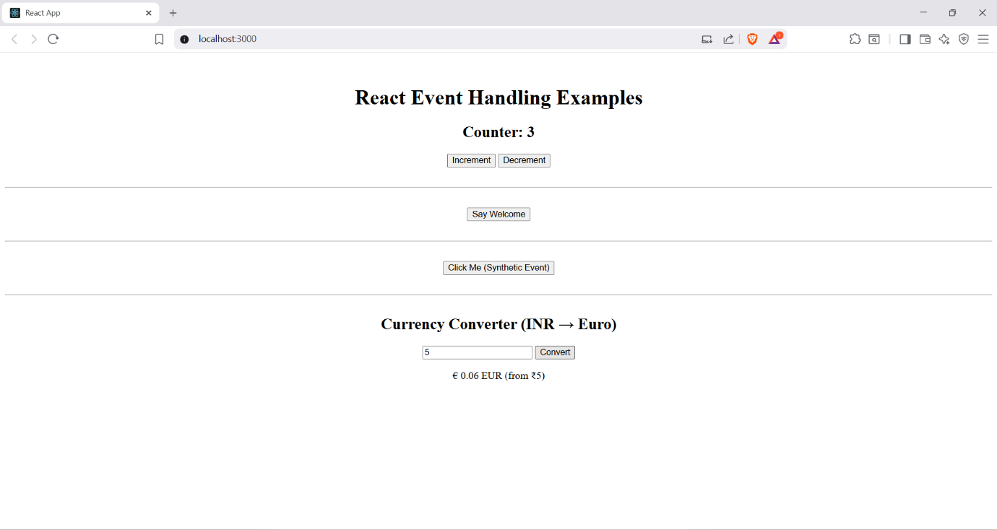
EX 12 TICKETBOOKINGAPP
Guest.js
import React from 'react';
const Guest = () => {
return (
<div style={styles.container}>
<h2>Welcome, Guest!</h2>
<p>You can browse flight details here, but booking requires login.</p>
</div>
);
};
const styles = {
container: {
textAlign: 'center',
marginTop: '50px',
},
};
export default Guest;
User.js
import React from 'react';

const User = () => {
return (
<div style={styles.container}>
<h2>Welcome, User!</h2>
<p>You can now book your flight tickets.</p>
</div>
);
};

const styles = {
container: {
textAlign: 'center',
marginTop: '50px',
},
};

export default User;
App.js
import React, { useState } from 'react';
import Guest from './components/Guest';
import User from './components/User';

function App() {
const [isLoggedIn, setIsLoggedIn] = useState(false);

const handleLoginToggle = () => {
setIsLoggedIn(prev => !prev);
};
const buttonStyle = {
marginTop: '20px',
padding: '10px 20px',
backgroundColor: isLoggedIn ? 'tomato' : 'green',
color: 'white',
border: 'none',
cursor: 'pointer',
borderRadius: '8px'
};
return (
<div style={{ textAlign: 'center' }}>
<h1>Ticket Booking App</h1>
{isLoggedIn ? <User /> : <Guest />}
<button style={buttonStyle} onClick={handleLoginToggle}>
{isLoggedIn ? 'Logout' : 'Login'}
</button>
</div>
);
}
export default App;
OUTPUT
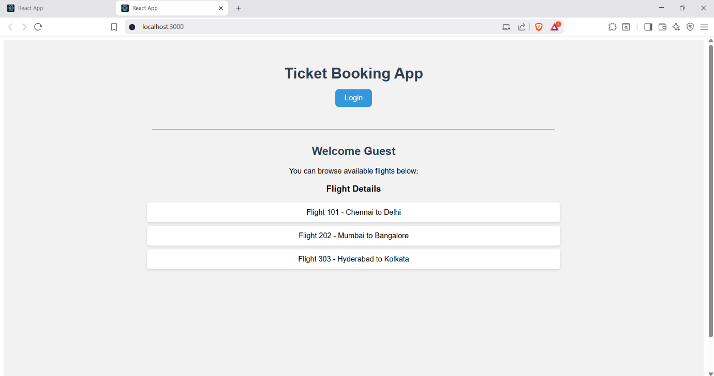
EX 13 BLOGAPP
BlogDetails.js
import React from 'react';
const BlogDetails = ({ blogs }) => {
return (
<div>
<h2>Blog Posts</h2>
<ul>
{blogs.map((blog) => (
<li key={blog.id}>
<strong>{blog.title}</strong> - {blog.content}
</li>
))}
</ul>
</div>
);
};
export default BlogDetails;
BookDetails.js
import React from 'react';
const BookDetails = ({ books }) => {
return (
<div>
<h2>Books List</h2>
<ul>
{books.map((book, index) => (
<li key={book.id}>
<strong>{book.title}</strong> by {book.author}
</li>
))}
</ul>
</div>
);
};
export default BookDetails;
CourseDetails.js
import React from 'react';

const CourseDetails = ({ courses }) => {
return (
<div>
<h2>Courses</h2>
<ul>
{courses.map((course) => (
<li key={course.id}>
<strong>{course.name}</strong> - {course.instructor}
</li>
))}
</ul>
</div>
);
};

export default CourseDetails;
App.js
import React, { useState } from 'react';
import BookDetails from './BookDetails';
import BlogDetails from './BlogDetails';
import CourseDetails from './CourseDetails';
import './App.css';

function App() {
const [view, setView] = useState('books');

const books = [
{ id: 1, title: 'React Explained', author: 'Zac Gordon' },
{ id: 2, title: 'Learning JavaScript', author: 'Ethan Brown' }
];

const blogs = [
{ id: 1, title: 'React Tips', content: 'Use hooks wisely' },
{ id: 2, title: 'JavaScript Trends', content: 'ES2025 is here!' }
];

const courses = [
{ id: 1, name: 'React Basics', instructor: 'Alice' },
{ id: 2, name: 'Advanced JS', instructor: 'Bob' }
];
let content;
if (view === 'books') {
content = <BookDetails books={books} />;
} else if (view === 'blogs') {
content = <BlogDetails blogs={blogs} />;
} else {
content = <CourseDetails courses={courses} />;
}

return (
<div className="App">
<h1>Blogger App</h1>
<div className="nav">
<button onClick={() => setView('books')}>Books</button>
<button onClick={() => setView('blogs')}>Blogs</button>
<button onClick={() => setView('courses')}>Courses</button>
</div>

<hr />
{content}
{/* {view === 'books' ? <BookDetails books={books} /> : view === 'blogs' ? <BlogDetails blogs={blogs} /> : <CourseDetails courses={courses} />} */}
{/* {view === 'books' && <BookDetails books={books} />}
{view === 'blogs' && <BlogDetails blogs={blogs} />}
{view === 'courses' && <CourseDetails courses={courses} />} */}
</div>
);
}

export default App;
OUTPUT
